**DAILY ONLINE ACTIVITIES SUMMARY**

|  |  |  |  |  |  |  |  |
| --- | --- | --- | --- | --- | --- | --- | --- |
| **Date:** | **24//06/2020** | | | | **Name:** | **Syed Rabeya Aamir** | |
| **Sem & Sec** | **8th B** | | | | **USN:** | **4AL16CS112** | |
| Online Test Summary | | | | | | | |
| **Subject** | | **----** | | | | | |
| **Max. Marks** | | **---** | | **Score** | | **---** | |
| Certification Course Summary | | | | | | | |
| **Course** | **Exam Readiness: AWS Certified Solutions Architect – Associate (Digital).** | | | | | | |
| **Certificate Provider** | | | **Aws** | **Duration** | | | **2 hrs** |
| Coding Challenges | | | | | | | |
| **Problem Statement:**  **1)**  Python Program for Fibonacci numbers. | | | | | | | |
| **Status: Solved** | | | | | | | |
| **Uploaded the report in Github** | | | | **YES** | | | |
| **If yes Repository name** | | | | **rabeya** | | | |
| **Uploaded the report in slack** | | | | **YES** | | | |

**Certification Course Details:**

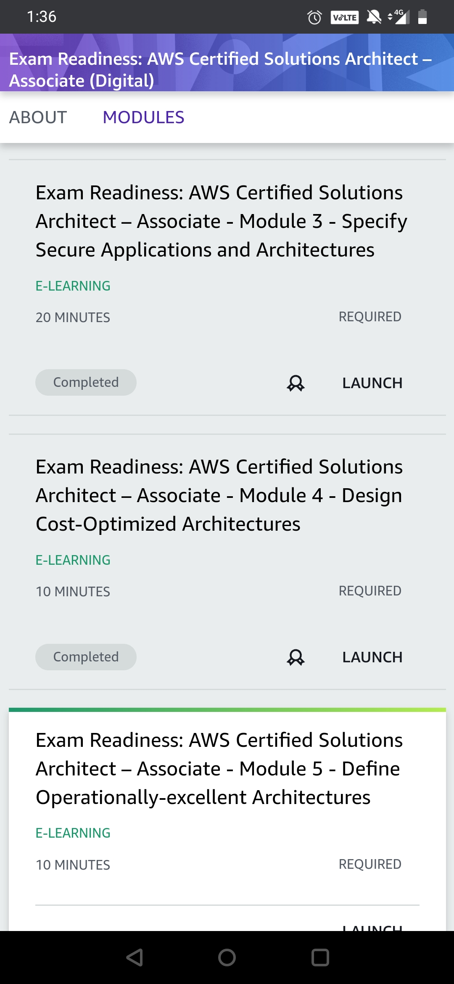

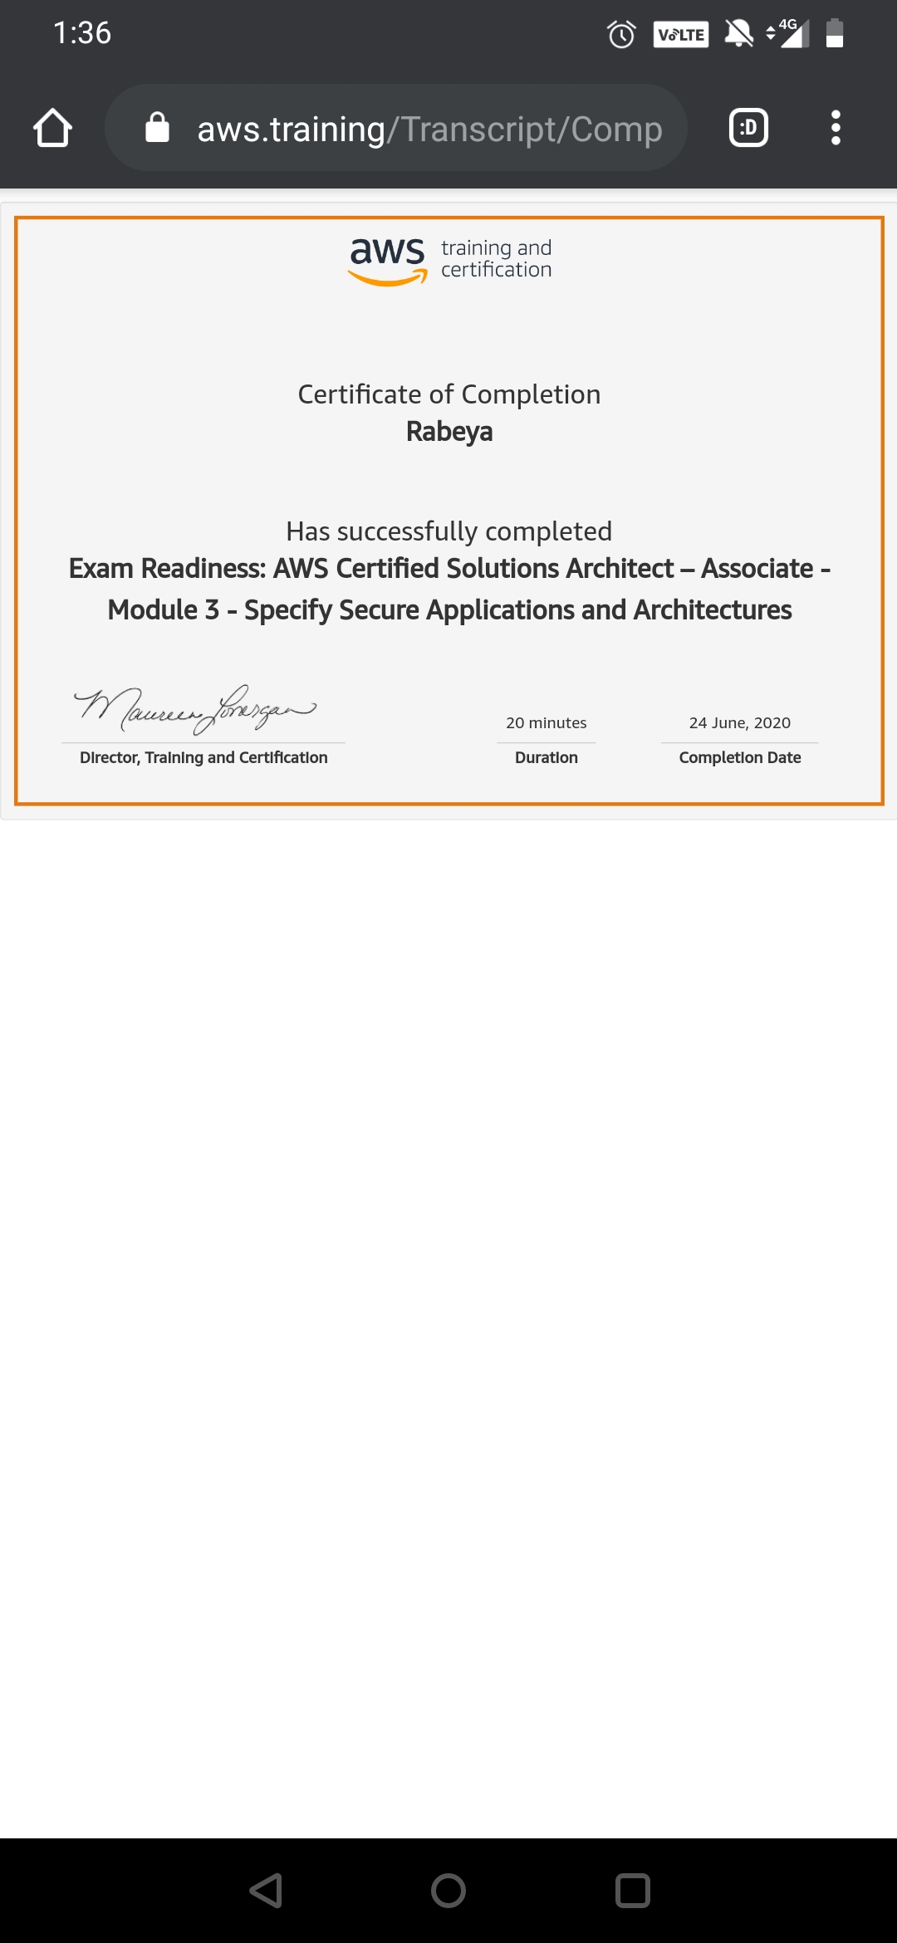

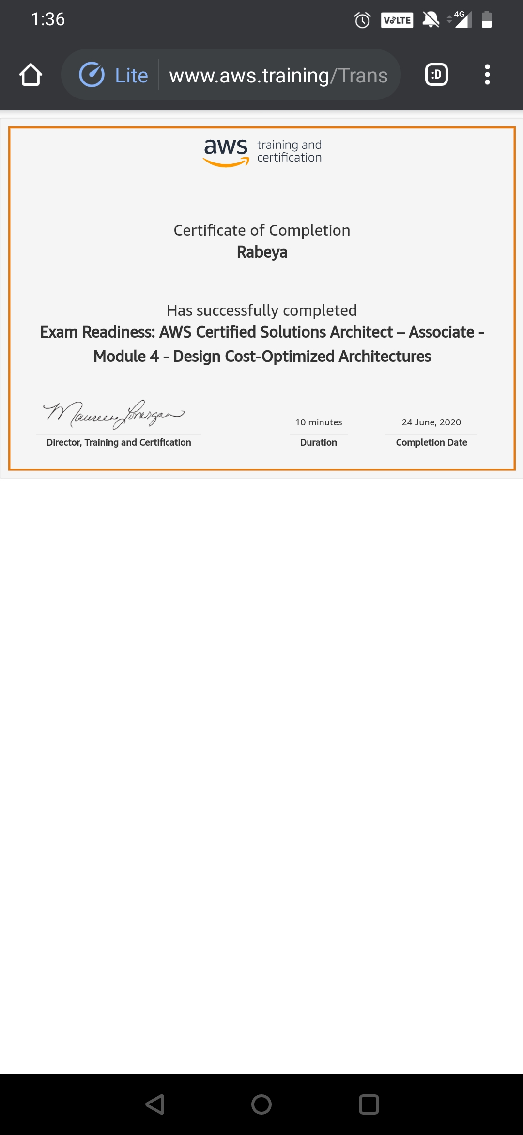

# CODE:

Program no:1

# Python Program for Fibonacci numbers.

# Function for nth fibonacci number - Space Optimisataion

# Taking 1st two fibonacci numbers as 0 and 1

def fibonacci(n):

a = 0

b = 1

if n < 0:

print("Incorrect input")

elif n == 0:

return a

elif n == 1:

return b

else:

for i in range(2,n):

c = a + b

a = b

b = c

return b

# Driver Program

print(fibonacci(9))